Audience Portal:

Complete Your Profile:

Phone Number: Shall we split with country code and then phone number?
Resolved (31 Jul 2026): Phone number is now entered as a country-code dropdown (UK +44 by default) plus the local number, on the profile/onboarding form and the event registration form. Admin can also edit the stored country code on a user's record.

Overview Section:

- Slight Update in the top cards:
- Events registered (participated)
- Selected for reward
- Verified attendance at events
- In progress
- Rewarded to date - (show underneath if the space cannot put 5 cards?)
Resolved (31 Jul 2026): Overview now shows all 5 cards in this order and with these labels, including the new 'Selected for reward' card. The grid is responsive (2 across on mobile, 3 on tablet, 5 on desktop), so cards wrap to a new row automatically on narrow screens rather than needing a fixed cut-off.

My events card can be titled as ‘My participated events’
Resolved (31 Jul 2026): The 'My events' quick-link card on the Overview page is now titled 'My participated events'.

My Events Section:

Currently the event shows as:

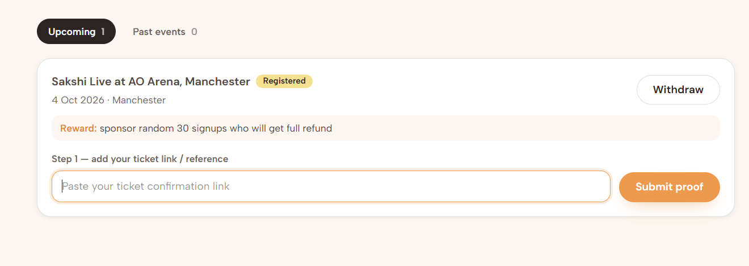

Can Venue Name also be added alongside Event Date and City
Resolved (31 Jul 2026): The venue name is now shown alongside the event date and location on each event card in My events.

Underneath 'reward', can we add additional things as well?
- Participation Deadline:
- Selection to be confirmed by: automatically calculate date one week after participation deadline
- Upload ticket proof: automatically calculate date one week after selection date
Update Step 1 sentence… to Next Step: upload your ticket proof if and after your selection has been confirmed
Instead of the ticket confirmation link, make the option as ticket upload
Resolved (31 Jul 2026): The reward panel on each event now also shows the Participation deadline and the auto-calculated 'Selection to be confirmed by' date (deadline + 1 week). Once selected, a 'Next Step: upload your ticket proof if and after your selection has been confirmed' section shows the auto-calculated upload-by date (selection date + 1 week). The old 'paste your ticket confirmation link' field has been replaced with an actual file upload (photo or PDF of the ticket), stored securely and viewable by the organiser/admin as 'Ticket proof'.

A few quick things to note (can add this section somewhere on My events page for easy reference)
- You will be notified via email if you are selected for the reward; alternatively, it will show on your overview section when you login to Live En Synergy website
- The selection is done within one week after the participation deadline. For example if the participation deadline is 01 Jan 2026, the selection will be carried out before 08 Jan 2026 and selected participants will be informed accordingly. If you don't receive any update by then, kindly assume that you were not selected on that occasion
- If you are selected, please buy ticket as you normally would and upload the ticket proof. Your ticket upload window will be available for one week (example till 15 Jan 2026), after that the option will expire and we will allocate your spot to someone else
- Attend the event and confirm your presence - this will be done either by scanning a QR code at the venue or artist can confirm direct when your ticket scans at the venue. The method will be mentioned on the event details
Resolved (31 Jul 2026): Added an 'A few quick things to note' card at the bottom of the My events page with these four points, worded to match. Note: the automatic reallocation of an expired spot to someone else is documented here as policy copy - the platform doesn't yet automatically reassign a lapsed spot to another registrant; that would be a separate follow-up if wanted.

General Question: Is there any possibility that we can freeze / suspend the account of an audience who gets selected but does not buy a ticket or attend a show for 3 times - suspend their account / participation for one year?
Resolved (31 Jul 2026): Built. Admin can mark a selected participant as a 'no-show' from the sponsored event's Participants list. On the 3rd no-show against an account (across any events), the account is automatically suspended for one year - same mechanism as a manual block - and the member is notified. The suspension lifts itself automatically once the year is up, or an admin can restore access manually at any time from the user's page.

